

WE’RE GOING!

Saturday 20th April 2024

The PSA are very excited to announce that we have been successful in gaining a place for the children at Preston Primary School to participate in the London Mini Marathon 2024! For those who expressed their attendance last year, a space has been guaranteed for you!
Adult Participation
Due to the extremely high number of entry’s this year, we have had to negotiate with the organisers as to how many adults are able to participate with their children. After lengthy discussions, we have agreed with the marathon organisers that ONE ADULT PER FAMILY WILL RUN WITH THEIR CHILDREN. For a majority of Preston families, this will result in a ratio of one adult to one/two children. I am aware of one family who will run at a ratio of 1:3. Even if the children run at different paces, it will be the responsibility of the participating adult to ensure they remain with their children, and that the children are accompanied at the end of the race. There are no finishers medals awarded for adults.
On The Day
We have been given at start time of 14.20. We have to be at the start line at Horse Guards Parade no later than 13.50.
The race is 1 mile long. The participants start at Horse Guards Parade, travelling up Birdcage Walk towards Buckingham Palace, before running around the water fountain and finishing along The Mall.
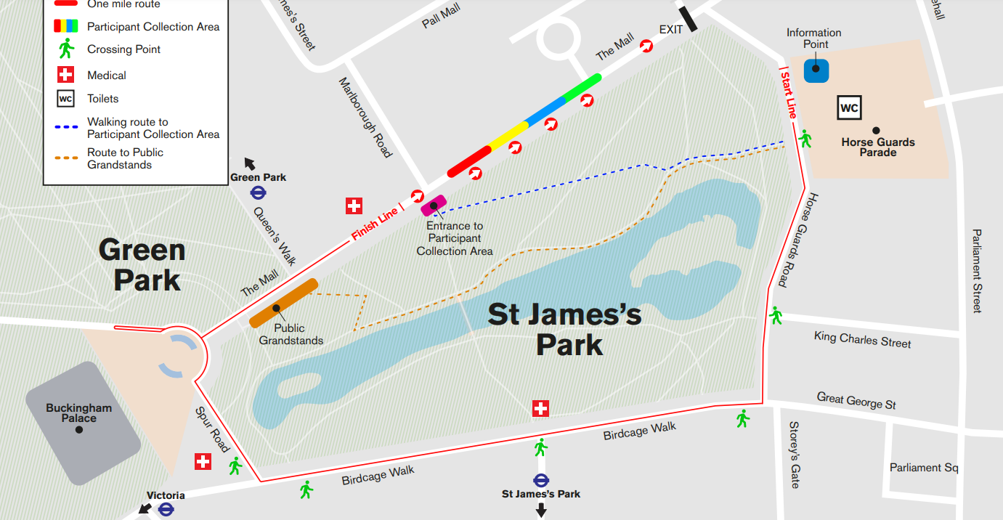

Each finisher will receive a well-earned medal, as well as £10 for the school to spend on new sports equipment or reading material. Bib numbers will be issued for all participants. Once we have received these, they will be distributed during the week before the event.
Additional spectators can line the streets along the route to cheer on our children. The more the merrier!
We aim to arrive in London approximately one hour before we are due at the start line. This will give the children enough time to have a light snack, a drink, and prepare themselves for the race. It is unlikely that there will be any food stalls close to the run course. Please bring snacks and a water bottle with you on the day, and a hat if it is sunny.
Travel Arrangements
Travelling to and from London will be down to each family. However, we have organised a team travel arrangement for the journey to London if you would like to join us as a larger group.
This is an off site event for Preston Primary School, and for this reason, each child and their safety will be the responsibility of the travelling adult.
Team Preston will leave Hitchin train station on the 11.41 train to Finsbury Park. From Finsbury Park we will then change and travel directly to Westminster underground. It would be advisable to purchase an all day travel card. Our estimated arrival time at Westminster underground is 12.35.
For those who wish to make their own way to London, that is not a problem. Team Preston will meet at the corner of St James’ Park near Birdcage Walk, shown by a yellow star on the map . The group travelling should arrive at this location by approximately 12.45.
Once the race has finished, please feel free to either spend the afternoon exploring London, or make your own way home.
Team T-Shirt
This is a big event for our children and the opportunity to be part of a team! It would be great (but not essential) for everyone to feel part of this with a team t-shirt. The printed t shirts will be £8 per child and £9 per adult.

London Mini Marathon 2024

If you would like to order a t-shirt, all orders must be received by 29th March 2024 in order to get them printed and delivered in time. Please follow the just giving details to pay and provide us with your sizes!
Just Giving Page: https://www.justgiving.com/campaign/minilondonmarathon2024
Confirming Your Place
If you would still like to participate in the Mini Marathon please fill out the consent form so that we know exactly who is attending, and text Faye (07773230487) with the following details:
- Child/children’s name
- The name of the adult participating
- Contact details of the adult travelling on the day
PLEASE CONFIRM ATTENDANCE BY 29th MARCH 2024

School Website Event Page: https://www.prestonjmi.herts.sch.uk/mini-london-marathon-saturday-20th-april-2024/

Any Questions?
We will be holding a zoom call at 7.30pm on Monday 25th March 2024 to run through all of the details regarding the Mini Marathon. If you have any questions regarding the event or any of the arrangements, please do join us!
Faye Frost is inviting you to a scheduled Zoom meeting.

Topic: London Mini Marathon 2024
Time: Mar 25, 2024 07:30 PM London

Join Zoom Meeting
https://us02web.zoom.us/j/3216689312?pwd=aUIwbFkrQzZTY1VqWTlabG5kZk5TUT09&omn=87034857646

Meeting ID: 321 668 9312
Passcode: 5wGUjy

This is such an exciting opportunity for our children to participate in a closed road event right in the centre of London whilst raising money for our school! Let’s make this one to remember!

